Analysis of Lifetime Commissions By Agent

The data used in this document comes from the AmeriLife data warehouse and the results are compiled from a live extract from the cubes. The data is, thus, accurate up to the previous night's processing.

## Rows Read: 67281, Total Rows Processed: 67281, Total Chunk Time: 3.739 seconds

To begin the analysis we will look at the data graphically. We will start with a global summary and drill down into detail following the indications that the data provides. We start with the distribution of lifetime commissions to AmeriLife from all agents; this distribution is derived from the history accumulated in the data warehouse, which starts in the 2013 - 2014 years. The distribution looks as follows:

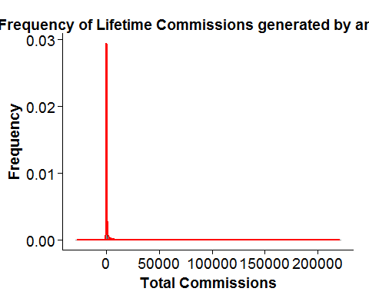

The Commissions range from a low (debt) of about $28,000 to a positive contribution of just over $220,000; the distribution of lifetime agent commisisons is heavily skewed, with a large contingen of agents that either do not contribute revenue to AmeriLife or are a debt burden to the organization. The basic statistics of this distribution are:

# Commissions  
summary(df$Commission)

## Min. 1st Qu. Median Mean 3rd Qu. Max.   
## -27990.0 0.0 0.0 478.7 102.0 220500.0

A manually binned histogram of those commissions by range of revenue looks as follows:

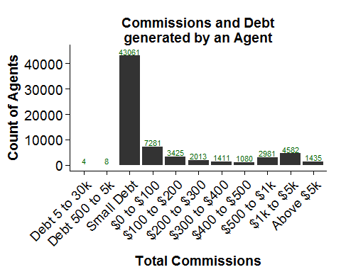

In tabular form:

## CommissionBinned Freq  
## 1 Debt 5 to 30k 4  
## 2 Debt 500 to 5k 8  
## 3 Small Debt 43061  
## 4 $0 to $100 7281  
## 5 $100 to $200 3425  
## 6 $200 to $300 2013  
## 7 $300 to $400 1411  
## 8 $400 to $500 1080  
## 9 $500 to $1k 2981  
## 10 $1k to $5k 4582  
## 11 Above $5k 1435

Given that enrolling an agent to sell for AmeriLife carries an initial estimated cost of $400, it behooves us to find out what are the attributes of agents that are capable of generating more that that amount in revenue through their lifetime.

Before leaving the analysis of lifetime commissions it is worth noting that at every level of revenue, there appears to be a larger number of direct agents vs. downline agents achieving that revenue. Here are some examples:

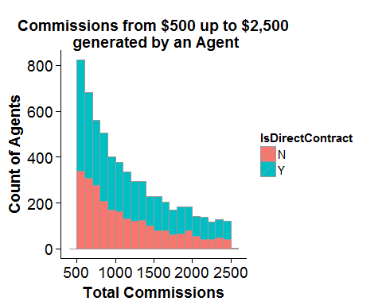

In this range of revenue generation, the proportion of direct vs. downline contracts is mor even than in any other range.

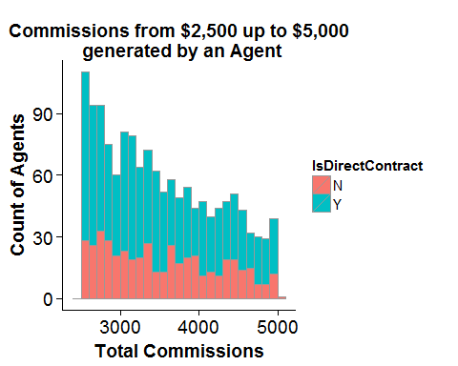

As revenue begins to increase, the proportion of direct agents generating the revenue increases with respect tot he downline agents generating the same volume of revenue.

